SEPTEMBER 2018 NEWSLETTER
WBHS DECA ADVISORS: julie.zalla@wbsd.org jacqueline.evola@wbsd.org laura.wowk@wbsd.org lisa.sallen@wbsd.org
Website: www.westbloomfield.deca.weebly.com Facebook: West Bloomfield High School Business Academy
Google Classroom: uc7xmgo Twitter: @wbhs_DECA Instagram: wbdeca VOL. 6 SEPTEMBER 2018

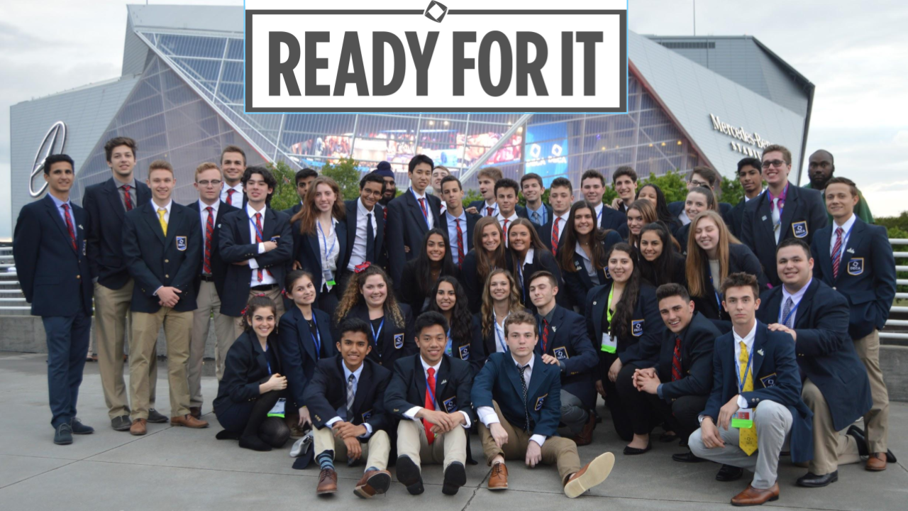

WELCOME!
Congratulations on joining the 2nd largest DECA Chapter in the State of Michigan. Over 250 WBHS students compete in DECA each year. This makes it the largest club at the high school. You are now a member of DECA with over 200,000 high school members from around the world!

DECA prepares emerging leaders and entrepreneurs in marketing, finance, hospitality and management. DECA prepares the next generation to be academically prepared, community oriented, professionally responsible and experienced leaders.

2018-2019 WBHS DECA OFFICERS ANNOUNCED
CEO – Ms. Zalla, Mrs. Evola, Ms. Wowk and Mrs. Sallen
PRESIDENT – ZACH CRAWFORD
SECRETARY- PAUL GAGNON
VP BUSINESS PARTNERSHIPS – ALEC VINCENT
VP CAREER DEVELOPMENT – DAVID MARTIN
VP CHAPTER DEVELOPMENT- ANDREW SCHWARTZ
VP COMMUNITY SERVICE – AYUSHI UPPAL
VP FINANCE – BRAD SIMTOB
VP HOSPITALITY – MAX BARASH
VP LEADERSHIP DEVELOPMENT – JAY RUBIN
VP MARKETING – NEVILLE KALLABAT
VP PUBLIC RELATIONS – MICHELLE GRIGOROV
CHAPTER REPORTER/HISTORIAN – NINA PERRY

2017 - 2018 WBHS DECA RECOGNITION AND AWARDS:
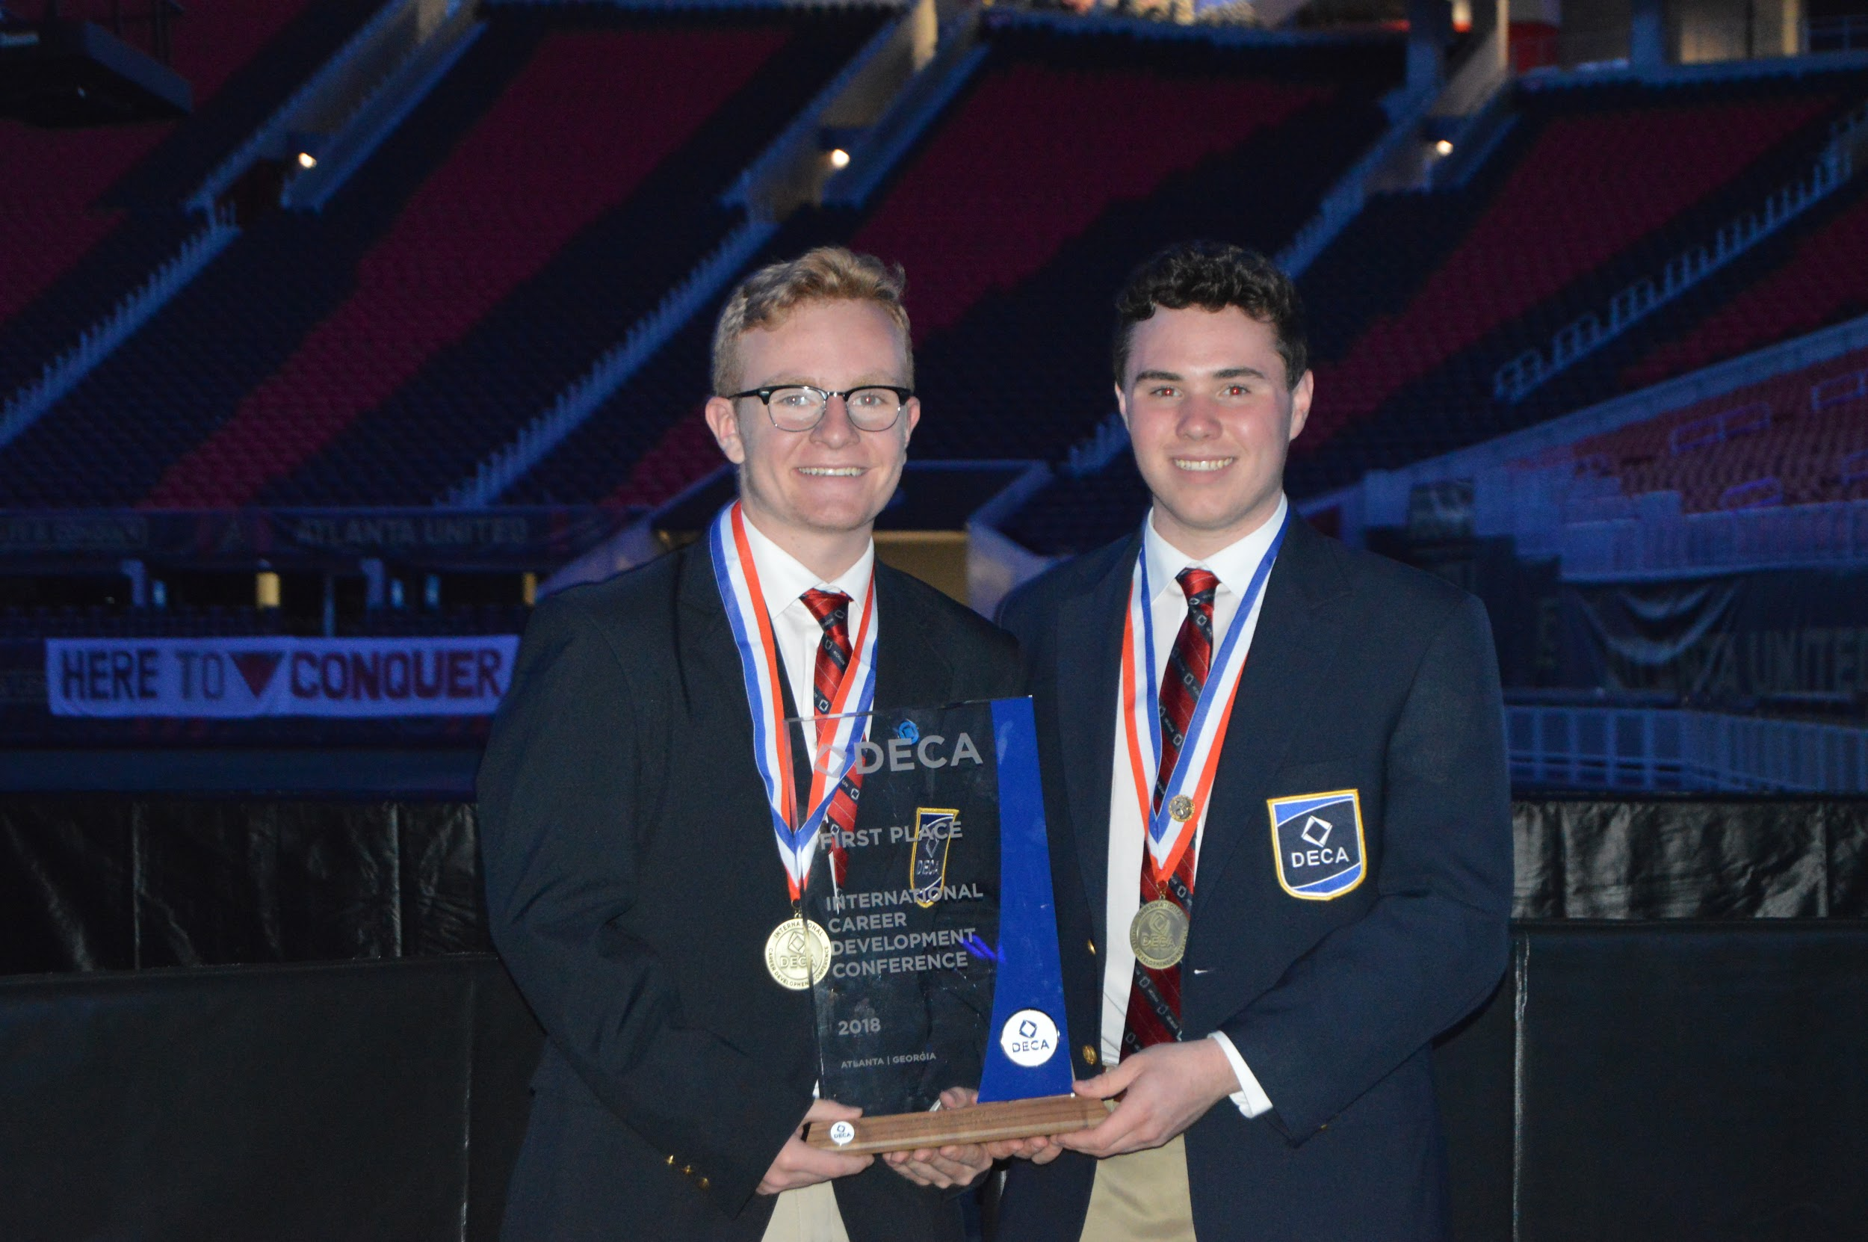
- DECA Emerging Leader Honor Award- Vietress Feller
- 1st place in the world DECA Virtual Business Sports Challenge and earning a $1000 prize- Matthew Ladouceur and Brian Bembas
- 4th place in the world in the DECA Virtual Business Hotel Challenge and winning an $800 prize- Rei Mizuno, Josh Carlin and Kasper Zemajitis
- 6th place in the world DECA Virtual Business
- Top 10 in the world in Business Operations Services- Kayla Zrepskey, Sydney Bruce and Lauren Gagnon
- Top 20 in the world in DECA Business Operations Research- Danielle Fink, Vietress Feller and Michelle
- 260 students participated in WBHS DECA making it the largest club at our school and the second largest chapter in Michigan.
- WBHS DECA Members Accepted to the top Business Schools in the United States.

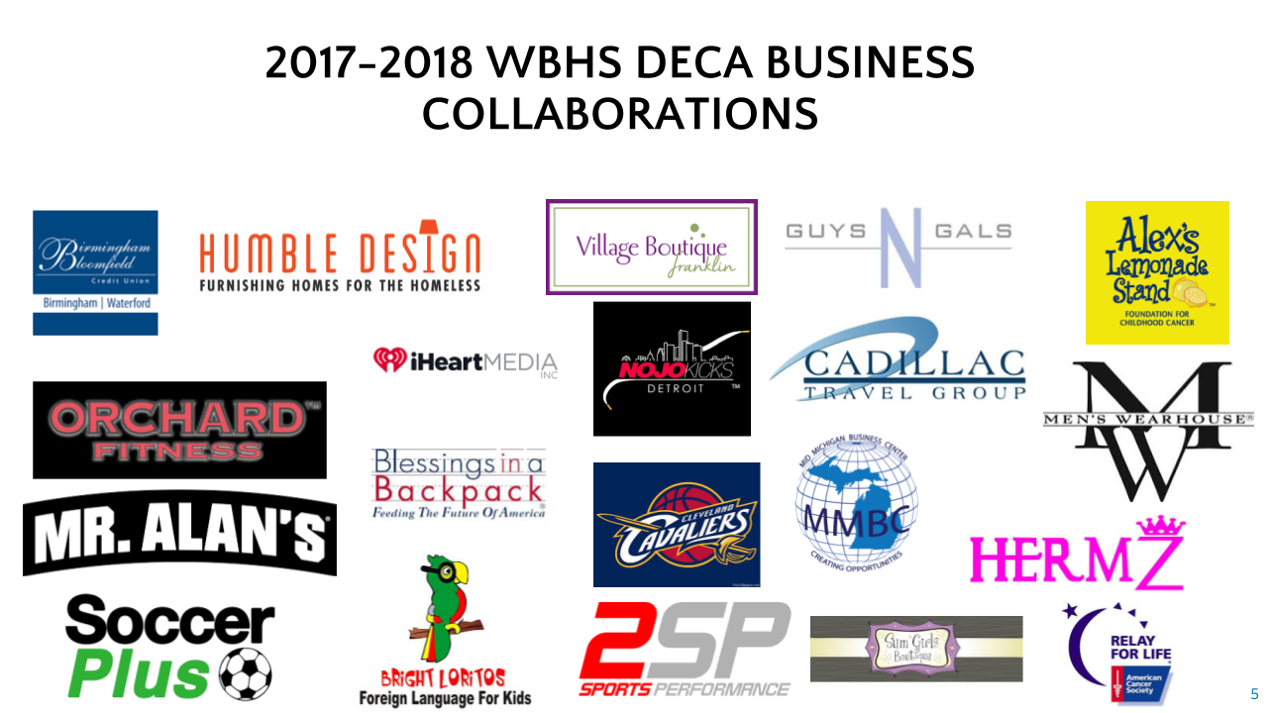
2017-2018 WBHS DECA BUSINESS PARTNERSHIPS

We are looking to partner with businesses for 2018-2019, be sure to contact julie.zalla@wbsd.org or visit www.westbloomfielddeca.weebly.com to learn more.

I AM SO EXCITED TO BE A NEW MEMBER!
HOW DO I KEEP INFORMED?!
- Favorite these Websites on your computer:
www.westbloomfielddeca.weebly.com
www.deca.org
www.mideca.org
- Google Classroom: Join Google classroom for copies of documents and to stay on top of due dates uc7xmgo
- Remind 101: Text 81010 with @9cabek to get text reminders.
- Twitter: Follow @wbhs_DECA for the latest WBHS DECA news.
- Facebook: “Like” the West Bloomfield High School Business Academy Facebook Page to see photos of yourself and friends throughout the school year.

DECA DUES - $35 BY SEPTEMBER 28TH
DECA is an OPTIONAL club students may join. The second page of this document gives you a guideline as to expected costs for each competition throughout the school year. Students who wish to compete in DECA this school year, should pay $35 made payable to West Bloomfield High School by September 28th to be include on the national roster. Students are to turn their money in directly to Mrs. Sallen (room 321) in the marketing office to fill out the paperwork, pay the $35 payment to West Bloomfield High School and recv the following:
- WBHS DECA T-shirt
- International DECA membership card
- DECA Participant Certificate
- Reduced cost for District and State Conference fees

DECA T-SHIRT DAYS ARE, “TOO COOL”
WBHS DECA students who pay their $35 dues will each receive a DECA T-shirt. Students will have an opportunities throughout each marking period to wear their DECA pride on selected dates to earn exemplary attitude bonus awards.
2018-2019 DECA COMPETITION DATES
DECA students MUST be available the following dates to compete. It is your responsibility to clear your schedule now of any appointments, speak with your employer as well as club/activity advisors. Students must qualify at districts to attend states. To attend the International conference, they must qualify at the state level.
WBHS LOCAL COMPETITION October 23, 2018
WBHS 6:45 AM-10:40 AM
DECA DISTRICT 6 COMPETITION December 14, 2018
Lawrence Tech 7AM-3:45PM
STATE CAREER DEV CONF March 8-10, 2018
Detroit, MI
INTERNATIONAL CAREER DEV CONF April 26-May 1, 2019
Orlando, Florida
2018-2019 ANTICIPATED CONFERENCE FEES
Participation in DECA is an optional activity. While most school districts require students to pay the full cost for each conference, we are pleased to be able to offer them at a discounted price. These prices are based on profits made from our fundraisers each card marking, profits from our school store, sponsorships and state money. These numbers may fluctuate. Students are encouraged to begin setting money aside to cover each of these expense upon being due.
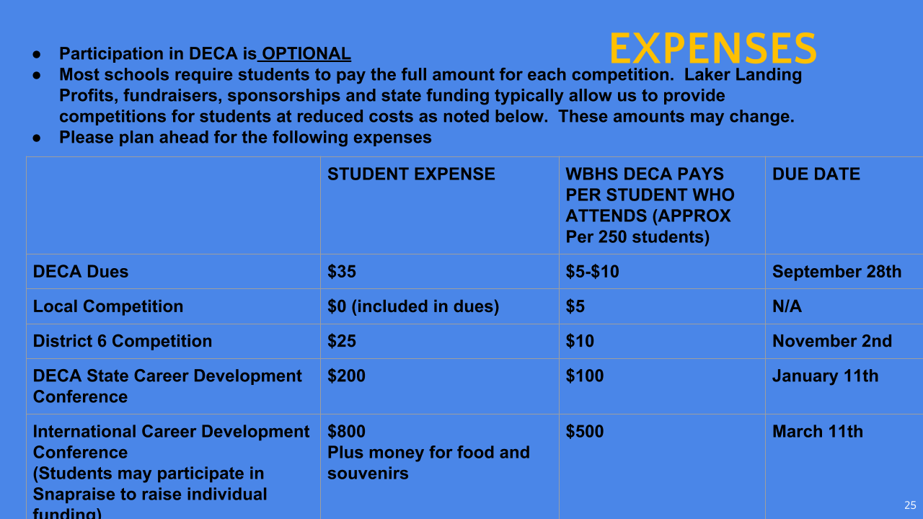
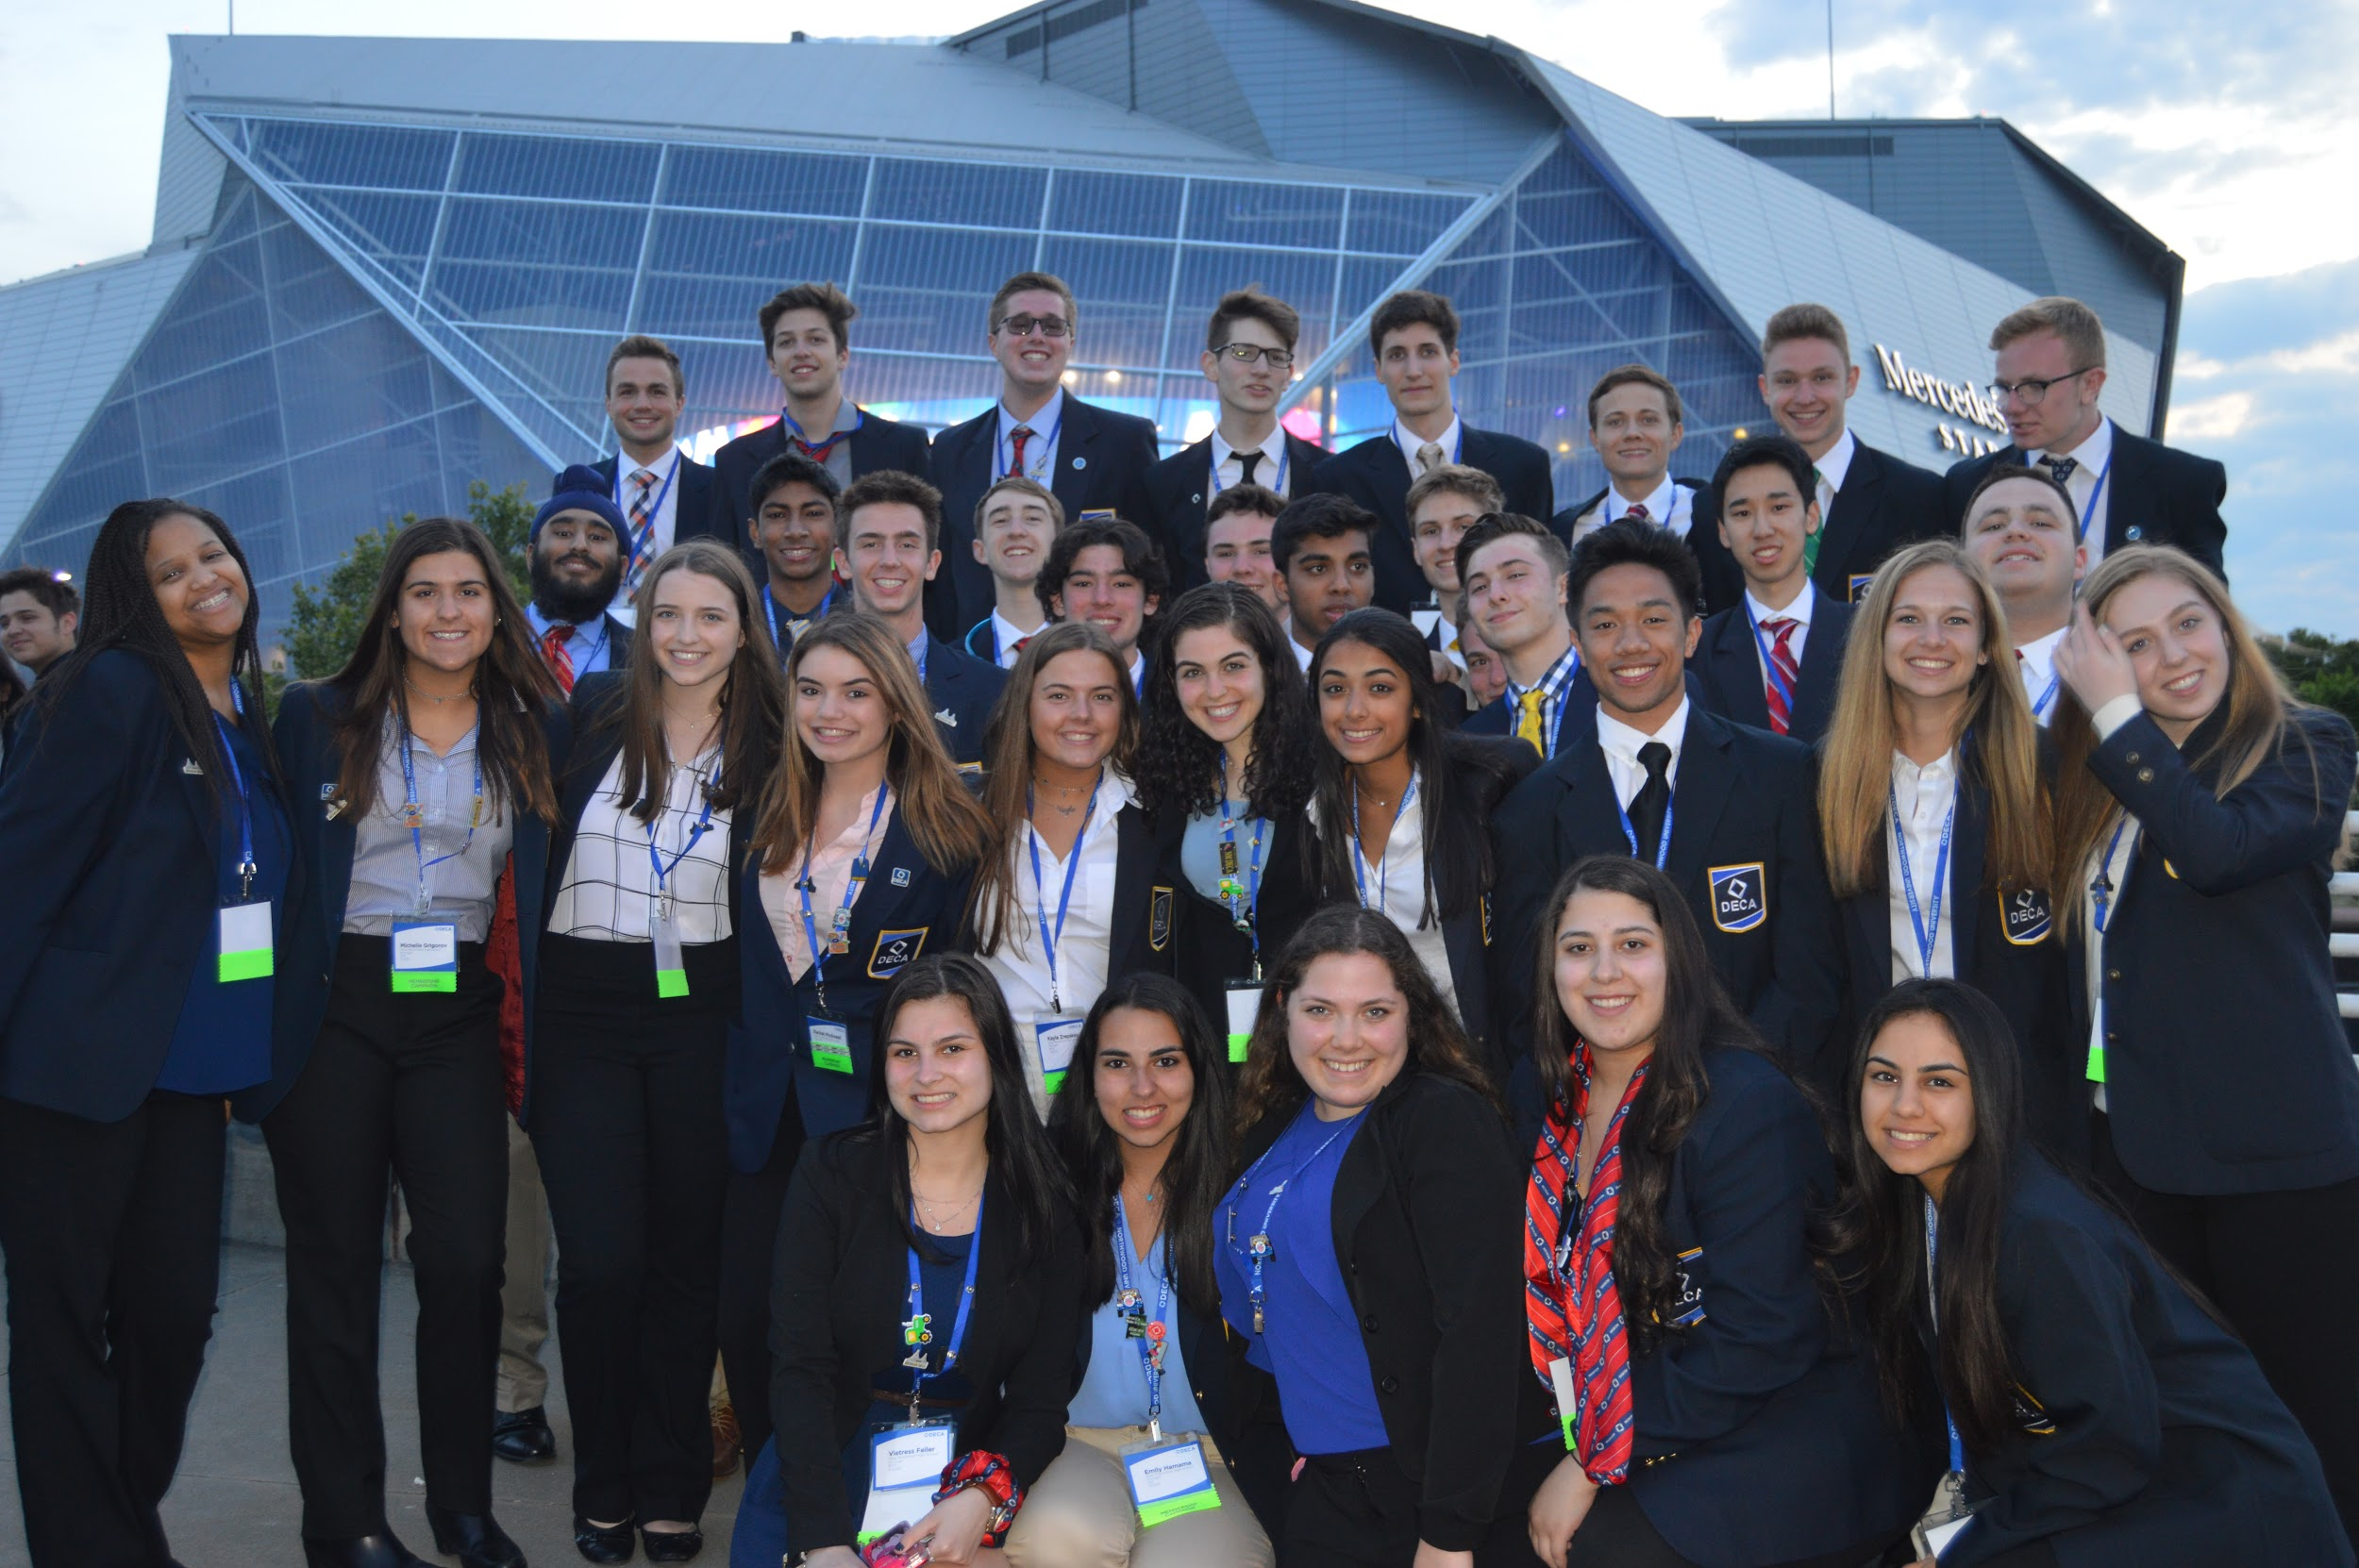
DECA DRESS CODE
One of DECA’s primary goals is to develop its members’ social intelligence by administering helpful advice on how to dress properly in business situations. Students participating in DECA will be getting dressed according to the following guidelines at least 4 times throughout the school year. While DECA has a website where you can purchase items (www.shopdeca.org), most of our students purchase their outfits at Kohl’s, Target or Express. They do not need to say DECA.
(https://www.shopdeca.org/collections/official-dress)
- Females - one of the options below:
- Business suit or blazer with a dress; dress shoes.
- Business suit or blazer, with a dress blouse, dress skirt or dress slacks; dress shoes.
- Official DECA Blazer with a dress; dress shoes.
- Official DECA Blazer with a dress blouse, dress skirt or dress slacks; dress shoes.
- All blouses and dresses must have covered arms and shoulders. Sleeveless blouses and dresses are acceptable if accompanied with a jacket, sweater or blazer. skirts should be at least fingertip length
- Advice from DECA seniors- “purchase a pair of comfortable FLAT dress shoes for competitions. Don’t wear heels.”
Males - one of the options below:
- Collared dress shirt, and necktie, blazer, dress slacks, dress shoes, and dress socks.
- Official DECA blazer with collared shirt and necktie, dress slacks, dress shoes, and dress socks.
- Advice from our DECA seniors- “Go to Kohl’s, Target or Express. Purchasing clothes that are wrinkle free or stain free are super helpful. Purchase inexpensive comfortable dress shoes and wear black socks.”
HOW DO I CHOOSE THE RIGHT COMPETITION TO COMPETE IN?
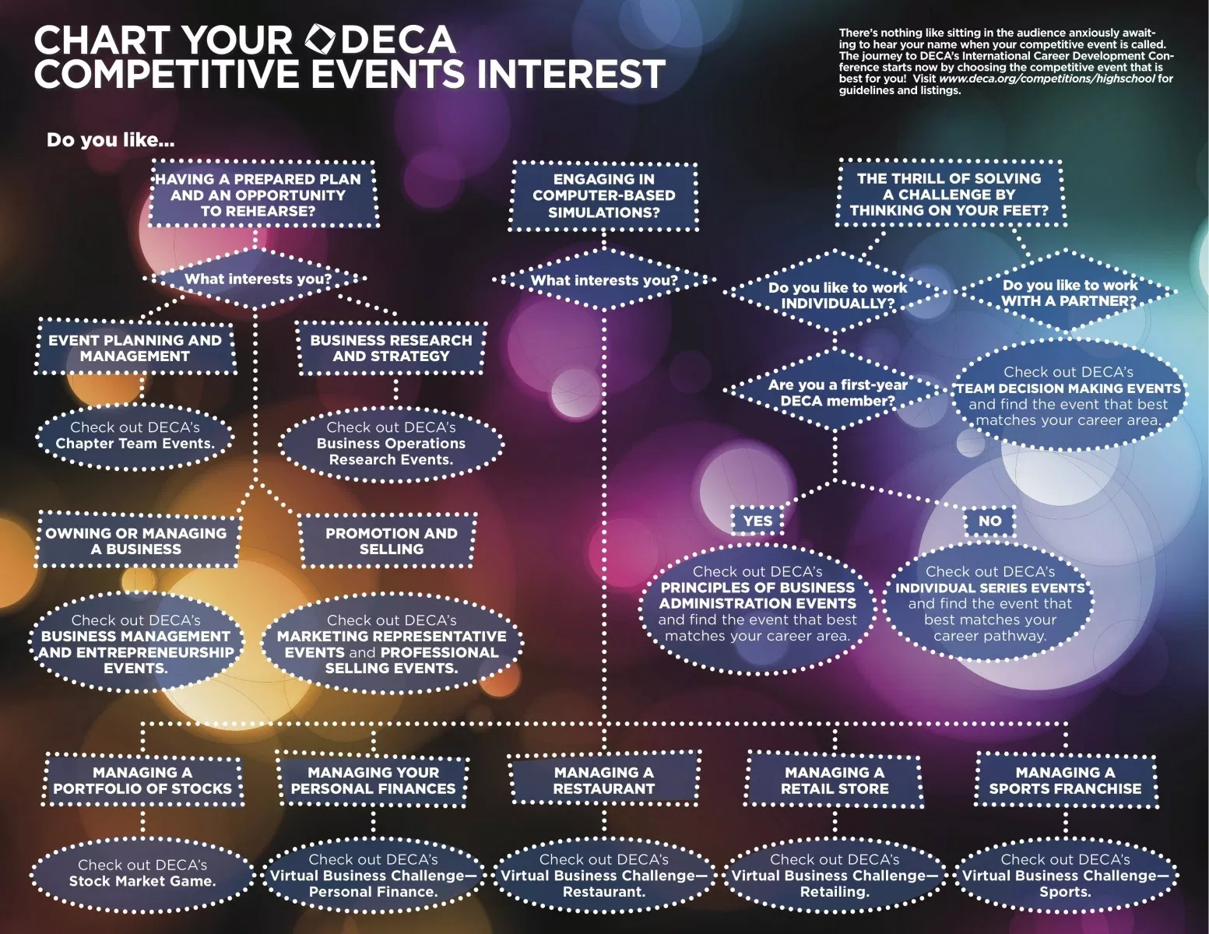
Have you have not already done so, visit www.deca.org and www.westbloomfielddeca.weebly.com to learn more. The following is National DECA’s suggestion for competition based on if this is your 1st, 2nd, 3rd or 4th year competing in DECA. After you complete one year, we at WBHS are somewhat more flexible on moving students up to other competitions based on students strengths.

Year 1 competitions on the chart give students experience and the basics for further events. The more business classes you have taken and the more years you have competed in DECA, the stronger competitor you become for the 3rd and 4th year events.
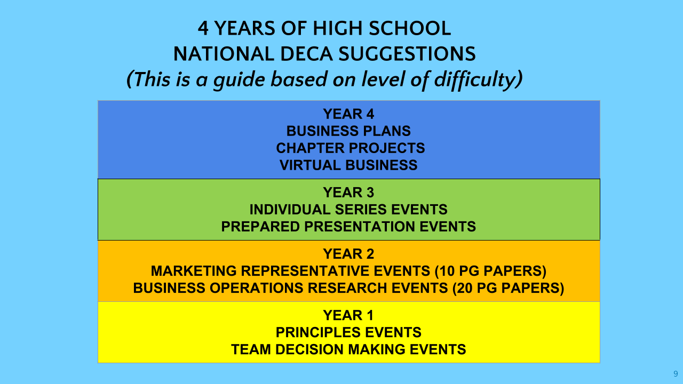
Below are some questions to ponder as you visit the websites above and hear your advisor talk about the different competitive events.
- Are you a first-time DECA competitor? The Principles of Business Administration events are an excellent way to get acquainted with DECA’s competitive events. Role-plays are written to be like a second job interview. The biggest advantage of this event is that you are competing against other first-time competitors, which levels the playing field
- Do you have a job somewhere? Even a small amount of experience can go a long way in your competitive events. You are more likely to understand the terminology on the exams and the performance indicators, and you should have a greater understanding of current trends within in your category.
- Do you know what you want to do for a career in the future or does something spark your interest? Use these competitive events to your advantage to find out now if these career areas are something you should continue to pursue.
- Do you work better as a team or as an individual? Many competitors want to work with a friend in the Team Decision Making events. Remember that DECA Inc. has written these team events with the intention that they will be for upper-level competitors (typically juniors or seniors). If you want to be able to make decisions on your own and don’t want to worry about how someone else’s test score may affect yours, then an Individual Series event would make sense.
- What courses have you taken or are you taking at WB? What you learn in these course prepares you for DECA competition.
- Are you a strong writer? Do you enjoy doing research? Are you in an AP writing class? Are you great at meeting due dates? Is this your second, third or fourth year competing? Consider competing alone or with a group of up to 3 in a written project.
- Do you like to think on your feet? Do you enjoy presenting to others? Are you a strong test taker and/or good at learning vocabulary words? Consider doing an individual or team role play which is available to all students.
- Do you enjoy playing virtual games on the computer? Are you in sports marketing, fashion, advanced marketing or accounting? Consider competing in one of the virtual business challenges.
- Have you checked out some sample events on DECA’s site? DECA’s website has a page dedicated to competitive events. By clicking on each of the different events, you will see event information, sample events, sample test questions and sample performance indicators. Some language and terminology will probably be more appealing to you. I would lean in the direction that seems most interesting to you or that you think you would be most comfortable with.
Visit www.deca.org and www.westbloomfielddeca.org to learn more. Speak with our DECA officers for further questions.

WHAT WILL I HAVE TO DO EACH CARD MARKING TO PREPARE AND EARN AN, “A”?
To make it easier to understand, we group our DECA students into one of the following categories. Remember, your activity choice (DECA or Independent Study) is 20% of each of your card marking grades.

DUE DATES ARE PROVIDED ON THE CLASS CALENDAR AND MUST BE MET TO CONTINUE

ROLE PLAYS (INDIVIDUAL, TEAM AND PRINCIPLE EVENTS)
Study: Each marking period you will be provided at least one test from a previous DECA Competition, business terms and their definitions as well as performance indicators to study. You will have at least four weeks to study them. You will be tested on this same information on the provided date on your class calendar.
Grading:
100
points DECA Test (on past DECA test provided, Vocabulary and Performance Indicators)
100 points Online Test for Competition
2nd marking period- District Competition online test
3rd marking period- State Career Development Conference Test
100 points Competition (must qualify at each competition to make it to the next)
Marking Period 1- Local Competition 10/23 at West Bloomfield High School
Marking Period 2 -District 6 Competition- 12/14 at Lawrence Tech
Marking Period 3- DECA State Career Development Conference - Detroit, Michigan
Marking Period 4- DECA International Career Development Conference- Orlando, Florida
100 points Completing the provided practice role play(s)
100 points Turning in of required documentation for DECA or conferences
*If student does not qualify for the following marking periods competition, they may move to DECA prep or Independent Study for their class activity grade.

DECA WRITTEN PROJECTS
100 points (each due date on the calendar)
You will have approx 2 weeks to make corrections to the previous version of your paper with the noted corrections, research information needed for that section of your paper and turning in 3 new single spaced typed
pages of your paper.
100 points DECA Test at the end of the card marking (all papers that are not 20 pages in length)
You will be provided DECA tests to study, industry terminology and definitions to study. You will study new
Information each marking period to prepare you for the DECA State Conference Test and/or DECA ICDC.
100 points Before the end of each card marking you will be required to turn in a copy of your paper proofread by an
English Teacher inside or outside of school, a parent/guardian or a business professional. You will need to turn
This in with their edits and signature.
100 points Attendance at 1-2 DECA after school help sessions provided by DECA or your teacher/advisor
100 points Marking period 3 only - DECA online test for State Conference
100 points Turning in of required documentation for DECA or conferences
Marking Period 3 and 4 only:
100 points Presentation slides
100 points Presentation to teacher
100 points presentation to class
100 points Presentation to business researched
*Students who do not qualify for DECA ICDC will move to DECA prep or Independent Study

VIRTUAL BUSINESS
1st and 2nd card marking:
- 100 points (each due date)
- Every 1-2 weeks you will need to complete a minimum of 1 simulation for your competition on the provided knowledge matters website. You earn the combined grade earned on the reading, math and simulation for each competition.
- 100 points turning in of required documentation for DECA or Conferences
3rd and 4th card marking:
- Only students who qualify for ICDC during the 1st or 2nd round of Semester 1 will continue with Virtual Business Semester 2.
- You will use the provided practice simulation from Knowledge Matters to prepare for DECA ICDC. Info to follow.

WHY WEST BLOOMFIELD HIGH SCHOOL DECA??

